SAMPLE SIZES
tx stage len.bin 3 5 7 9 11 13 15 17
8BF Fem 0 0 1 11 2 5 5 0
Grav 0 0 0 0 0 0 0 0
Juv 0 2 9 1 0 0 0 0
Male 0 0 0 2 5 11 0 0
8SBF Fem 0 0 4 10 11 20 14 1
Grav 0 0 0 0 0 12 12 3
Juv 2 20 23 3 0 0 0 0
Male 0 0 0 5 12 32 1 0
Fresh Fem 0 0 3 11 10 19 13 5
Grav 0 0 0 0 1 12 6 3
Juv 1 19 16 0 0 0 0 0
Male 0 0 2 9 15 23 5 0

DESCRIPTIVE STATISTICS
Min. 1st Qu. Median Mean 3rd Qu. Max. StDev
$`Fem:8BF` 8.900000 9.800000 11.000000 11.990000 14.350000 16.000000 2.522752
$`Fem:8SBF` 8.20000 11.60000 13.85000 13.15000 14.90000 18.00000 2.53988
$`Fem:Fresh` 8.600000 11.500000 13.800000 13.420000 15.100000 18.300000 2.610534
$`Grav:8BF` NULL
$`Grav:8SBF` 13.700000 14.400000 15.100000 15.290000 15.850000 17.900000 1.129569
$`Grav:Fresh` 12.900000 14.150000 14.700000 15.160000 16.450000 18.200000 1.513604
$`Juv:8BF` 6.800000 7.225000 7.600000 7.708000 8.175000 9.000000 0.7292067
$`Juv:8SBF` 4.000000 6.100000 7.200000 7.127000 8.200000 9.900000 1.327730
$`Juv:Fresh` 4.800000 6.075000 6.800000 6.850000 7.625000 8.800000 1.079021
$`Male:8BF` 10.400000 12.550000 13.100000 13.010000 14.120000 14.600000 1.257396
$`Male:8SBF` 9.100000 12.620000 13.300000 13.180000 14.250000 15.100000 1.473931
$`Male:Fresh` 8.100000 11.450000 13.100000 12.870000 14.470000 15.800000 1.890892

RAW PLOT OF DATA – ORIGINAL SCALE
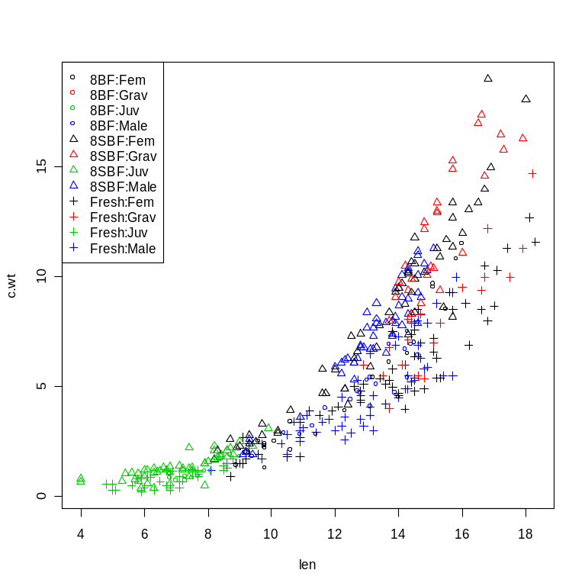
RAW PLOT OF DATA – TRANSFORMED SCALE
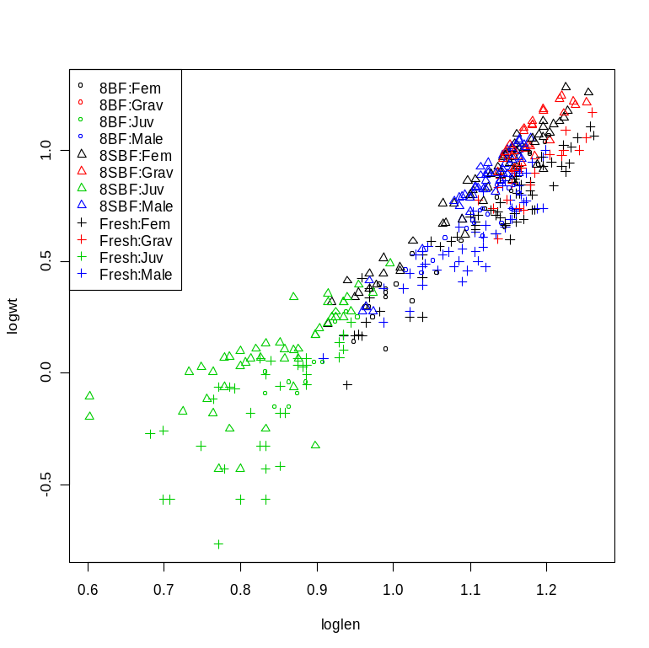

This is the start of problems – notice the very much higher variability about the juveniles (lower left – in green). The variability seems to be largely associated with the sugar buffered formalin (8SBF – triangles) and fresh (plusses). Also, notice the two shortest individuals – their weights seem too large for their length. A few other “outliers” had been removed prior to this figure.

INITIAL MODEL FIT – ALL BUT GRAVID FEMALES, ALL THREE TREATMENTS
At this point I removed the gravid individuals from the analysis as we did not have any gravid individuals in the 8BF treatment. Thus, I will look for differences among all three treatments for males, females, and juveniles.

Anova Table (Type II tests)
Response: logwt
Sum Sq Df F value Pr(>F)
loglen 15.4189 1 1423.9329 < 2.2e-16 ***
tx 2.8877 2 133.3404 < 2.2e-16 ***
stage 0.0266 2 1.2277 0.29424
loglen:tx 0.0228 2 1.0516 0.35048
loglen:stage 0.3023 2 13.9582 1.482e-06 ***
tx:stage 0.0272 4 0.6286 0.64242
loglen:tx:stage 0.1110 4 2.5636 0.03823 *
Residuals 3.7358 345

There is a significant three-way interaction in this model implying that slopes differ among all treatment and stage combinations (but not predictably along just treatments or just stages). False Discovery Rate (FDR) post-hoc analysis (below) of treatment:stage slopes indicates that the 8SBF:Juv group is significantly different (shallower) from five of the other eight groups. No other significant differences were detected. Two “outliers” – the two shortest juveniles mentioned above – seemed to potentially “pull up” the left side of the juvenile line, causing the shallower slope (see figure below next table).

Multiple comparison control procedures used: FDR
Slope Comparisons : Estimated eta0= 1 ; P-value cut-off= 0.00036
Slopes : Estimated eta0= 1 ; P-value cut-off= 4e-05

Multiple Slope Comparisons
comparison diff lwr upr raw.p adj.p significant
11 8SBF:Juv-8BF:Juv -1.45562 -3.01324 0.10199 0.06691 0.21898 FALSE
17 8SBF:Juv-8BF:Male -0.93431 -2.12411 0.25549 0.12338 0.32814 FALSE
29 Fresh:Juv-8SBF:Juv 0.61859 0.01719 1.21999 0.04383 0.19723 FALSE
4 8SBF:Juv-8BF:Fem -1.42738 -2.01270 -0.84207 0.00000 0.00000 TRUE
22 8SBF:Juv-8SBF:Fem -1.19292 -1.64843 -0.73740 0.00000 0.00000 TRUE
27 8SBF:Male-8SBF:Juv 1.59742 0.95173 2.24311 0.00000 0.00000 TRUE
28 Fresh:Fem-8SBF:Juv 0.99610 0.54256 1.44965 0.00002 0.00018 TRUE
30 Fresh:Male-8SBF:Juv 0.99124 0.45071 1.53178 0.00036 0.00259 TRUE

Slope Information
level slopes lwr upr raw.p adj.p significant
5 8SBF:Juv 1.77602 1.42974 2.12230 0e+00 0e+00 TRUE
8 Fresh:Juv 2.39461 1.90291 2.88631 0e+00 0e+00 TRUE
3 8BF:Male 2.71033 1.57203 3.84862 0e+00 0e+00 TRUE
9 Fresh:Male 2.76726 2.35222 3.18231 0e+00 0e+00 TRUE
7 Fresh:Fem 2.77213 2.47922 3.06503 0e+00 0e+00 TRUE
4 8SBF:Fem 2.96894 2.67299 3.26489 0e+00 0e+00 TRUE
1 8BF:Fem 3.20340 2.73151 3.67529 0e+00 0e+00 TRUE
2 8BF:Juv 3.23164 1.71301 4.75028 4e-05 4e-05 TRUE
6 8SBF:Male 3.37344 2.82846 3.91842 0e+00 0e+00 TRUE

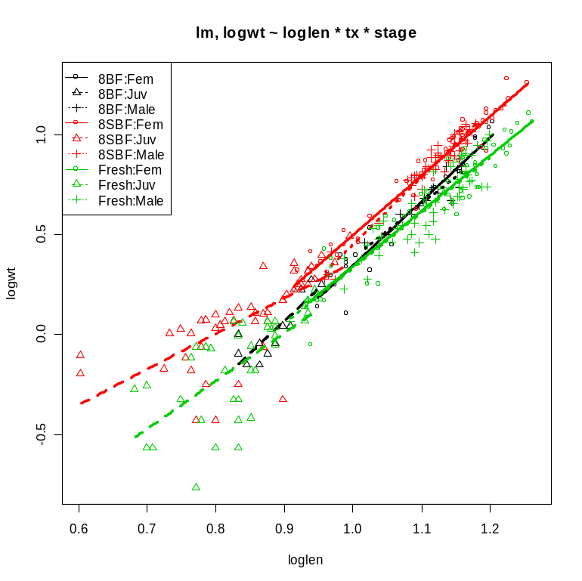

The analysis without the two individuals does NOT have the three-way interaction. There is, however, a two-way interaction with loglen and stage indicating that the slope of the regression lines differs by stage.

Anova Table (Type II tests)
Response: logwt
Sum Sq Df F value Pr(>F)
loglen 15.6914 1 1491.0271 < 2.2e-16 ***
tx 2.7227 2 129.3601 < 2.2e-16 ***
stage 0.0064 2 0.3056 0.736855
loglen:tx 0.0331 2 1.5727 0.208983
loglen:stage 0.1165 2 5.5337 0.004312 **
tx:stage 0.0297 4 0.7051 0.588898
loglen:tx:stage 0.0476 4 1.1309 0.341728
Residuals 3.6097 343

FDR post-hoc analysis indicates that the slope for juveniles was significantly shallower than the slopes for both males and females and the slopes for males and females were not different.

At this point I decided to separate the groups into adults (male and female), juveniles, and gravid to look at the effect of treatment.

ANALYSIS OF JUST MALES AND FEMALES, ALL THREE TREATMENTS
The analysis of males and females indicates that there is a difference in slopes among treatments, but not by stage (in addition the two-way intercept interactions (tx:stage) and three-way interactions were not significant). One might wonder why this happened (i.e., there was no treatment effect evident in previous analyses). I think that the issue is that the removal of the juveniles substantially reduced the overall variability increasing the power of the analysis (i.e., total SS and residual SS below is substantially smaller than above)..

FDR post-hoc analysis indicated that the fresh samples were weakly (q-value=0.06) but not ultimately significantly different from the 8SBF and 8BF groups (the 8SBF and 8BF were not significantly different). This is a decision point for us – the ANOVA suggests significance but the FDR does not. My gut is to conclude that there are not significant differences (look at the plot below – note that the male female lines are generally right on top of each other).

Anova Table (Type II tests)
Response: logwt
Sum Sq Df F value Pr(>F)
loglen 13.5406 1 2586.8065 < 2e-16 ***
tx 1.9337 2 184.7045 < 2e-16 ***
stage 0.0032 1 0.6146 0.43380
loglen:tx 0.0405 2 3.8644 0.02222 *
loglen:stage 0.0029 1 0.5626 0.45389
tx:stage 0.0012 2 0.1099 0.89593
loglen:tx:stage 0.0216 2 2.0621 0.12930
Residuals 1.3348 255

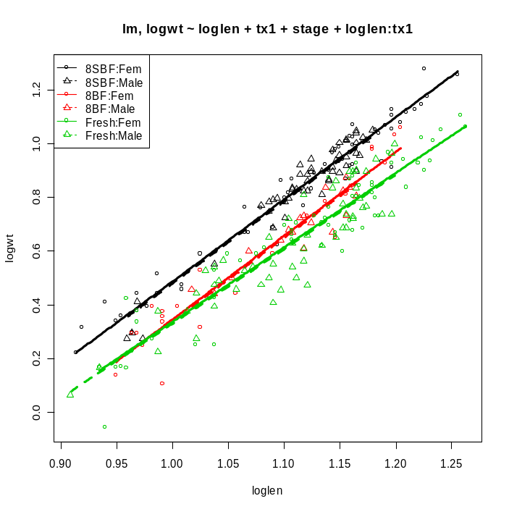
If we conclude that the slopes are not different (all parallel lines) then FDR post-hoc analysis on the intercepts suggests that all three lines have different intercepts. The 8SBF is between 0.108 and 0l.170 (on the log scale) higher than the 8BF, the 8BF is between 0.0122 and 0.074 higher than the Fresh, and the 8SBF is between 0.160 and 0.205 higher than the Fresh group at all values of log length.

Tukey HSD on adjusted means assuming parallel lines.
comparison diff lwr upr p.adj
1 8SBF-8BF 0.13926337 0.10813866 0.1703881 1.983969e-13
2 Fresh-8BF -0.04318308 -0.07412027 -0.0122459 3.254687e-03
3 Fresh-8SBF -0.18244646 -0.20533143 -0.1595615 1.739719e-13

Mean adjusted values at a covariate value of 1.10885173136164
8BF 8SBF Fresh
0.6790600 0.8183234 0.6358769

ANALYSIS OF JUST JUVENILES, ALL THREE TREATMENTS
There is no significant difference in slopes among treatments for the juvenile mysis (note that the two “outliers” mentioned previously have been included in the dataset). However, there is a significant difference in the intercepts. The 8SBF is between 0.019 and 0.270 (on the log scale) higher than the 8BF, the 8BF is between 0.060 and 0.200 higher than the Fresh, and the 8SBF is between 0.128 and 0.214 higher than the Fresh group at all values of log length.

Anova Table (Type II tests)
Response: logwt
Sum Sq Df F value Pr(>F)
loglen 2.21337 1 82.9665 2.043e-14 ***
tx 0.96988 2 18.1775 2.340e-07 ***
loglen:tx 0.07177 2 1.3451 0.2657
Residuals 2.40101 90

Tukey HSD on adjusted means assuming parallel lines.
comparison diff lwr upr p.adj
1 8SBF-8BF 0.14494261 0.01959277 0.27029244 1.921561e-02
2 Fresh-8BF -0.06913642 -0.19859716 0.06032433 4.145290e-01
3 Fresh-8SBF -0.21407902 -0.29970926 -0.12844878 1.377603e-07

Mean adjusted values at a covariate value of 0.84446448716716
8BF 8SBF Fresh
-0.06324223 0.08170038 -0.13237864

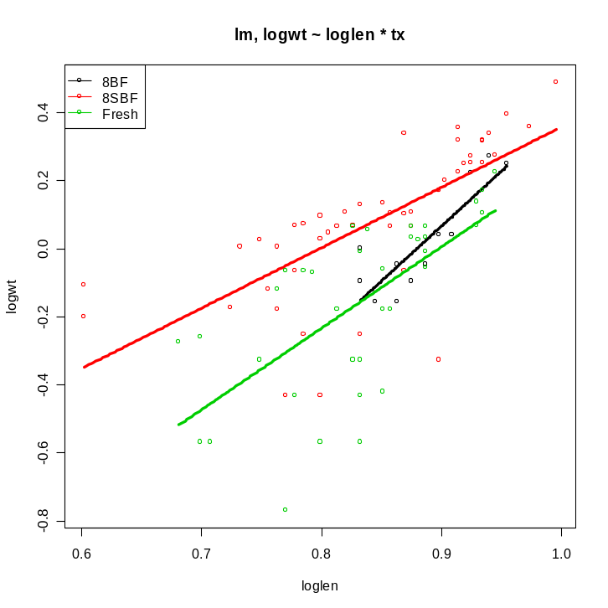

ANALYSIS OF JUST GRAVIDS, 8SBF and FRESH TREATMENTS
There is no significant difference in slopes among treatments for the gravid mysis. However, there is a significant difference in the intercepts. The 8SBF is between 0.132 and 0.207 (on the log scale) higher than the Fresh group at all values of log length.

Anova Table (Type II tests)
Response: logwt
Sum Sq Df F value Pr(>F)
loglen 0.46432 1 108.5329 1.420e-13 ***
tx 0.34693 1 81.0924 1.246e-11 ***
loglen:tx 0.00093 1 0.2174 0.6433
Residuals 0.19252 45

Tukey HSD on adjusted means assuming parallel lines.
comparison diff lwr upr p.adj
1 Fresh-8SBF -0.1694769 -0.2065458 -0.1324081 2.671419e-12

Mean adjusted values at a covariate value of 1.18120295716011
8SBF Fresh
1.0641082 0.8946312

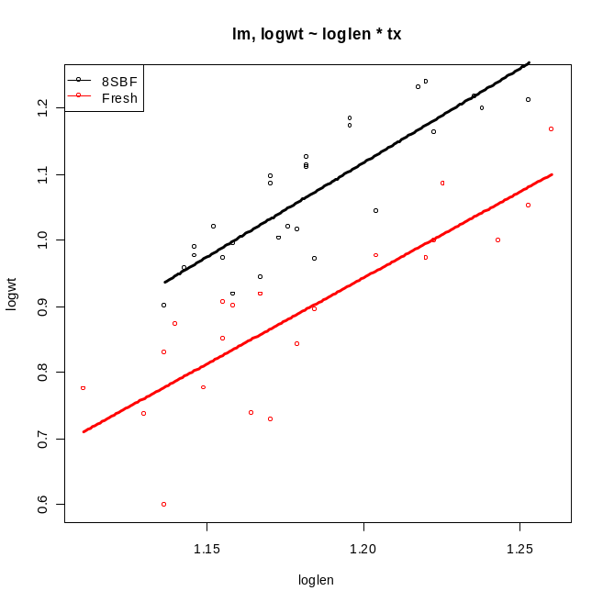
ANALYSIS OF ALL BUT JUVENILES, 8SBF and FRESH TREATMENTS
There is a significant difference in slopes among treatments.

Anova Table (Type II tests)
Response: logwt
Sum Sq Df F value Pr(>F)
loglen 11.8511 1 2321.4668 < 2e-16 ***
tx 2.1913 1 429.2479 < 2e-16 ***
stage 0.0598 2 5.8562 0.00325 **
loglen:tx 0.0321 1 6.2905 0.01274 *
loglen:stage 0.0089 2 0.8702 0.42007
tx:stage 0.0101 2 0.9846 0.37497
loglen:tx:stage 0.0110 2 1.0751 0.34276
Residuals 1.3375 262

